EXERCISE 6.1

Question 1:

Fill in the blanks by using the correct word given in brackets.  
(i) All circles are ……………. . (congruent/similar)  
(ii) All squares are …………… . (similar/congruent)  
(iii) All …………….. triangles are similar. (isosceles/equilateral)  
(iv) Two polygons of the same number of sides are similar, if  
(a) their corresponding angles are …………… and  
(b) their corresponding sides are …………… (equal/proportional)

Solution:

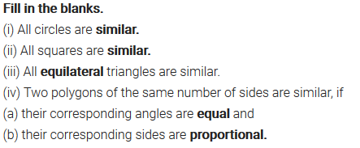

Question 2:

Give two different examples of pairs of  
(i) similar figures.  
(ii) non-similar figures.

Solution:

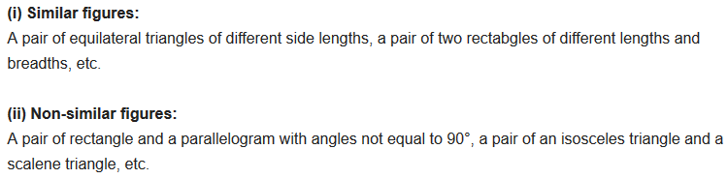

Question 3:

State whether the following quadrilaterals are similar or not.  
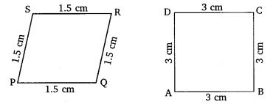

Solution:

